Overview Screen for Aquarium Mobile. Top buttons for Shortcuts to ReefBeat and Hydros apps. Need to create shortcuts to launch.
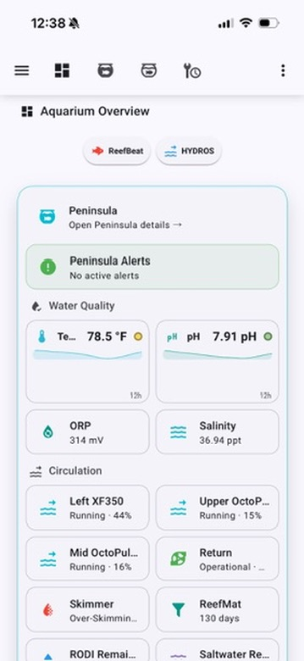 | 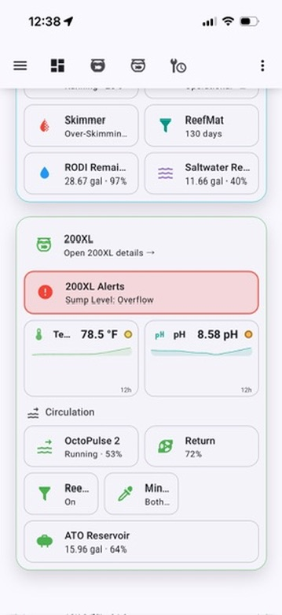

Tank specific View. Alerts in green shown. When any active alerts will be displayed and turn red. Other Active Devices are devices that do not run continuously.  Measurements show the previous 12 hours.  Wave pumps emulate Red Sea ReefBeat but are controlled by Hydros WEv2. Shows pump name and schedule currently running along with the direction.  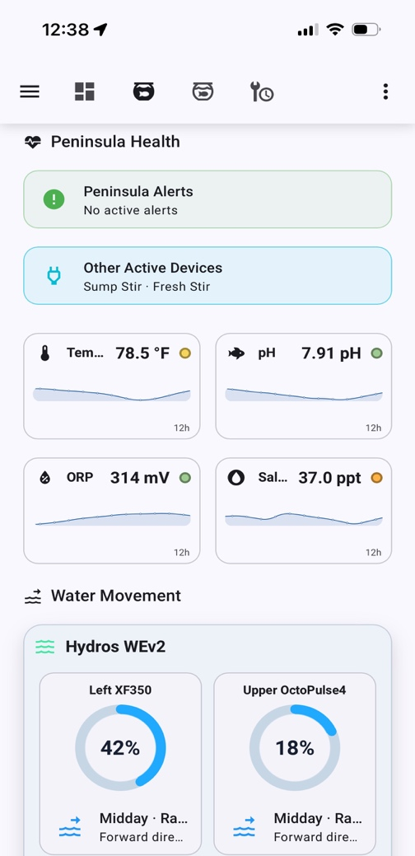 | Wave pumps continued. Below are Red Sea ReefRun devices that look like ReefBeat.  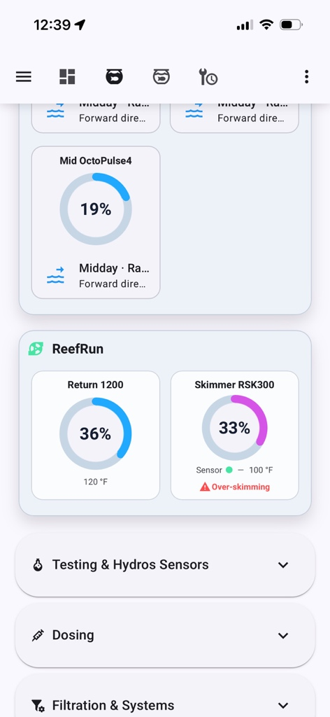

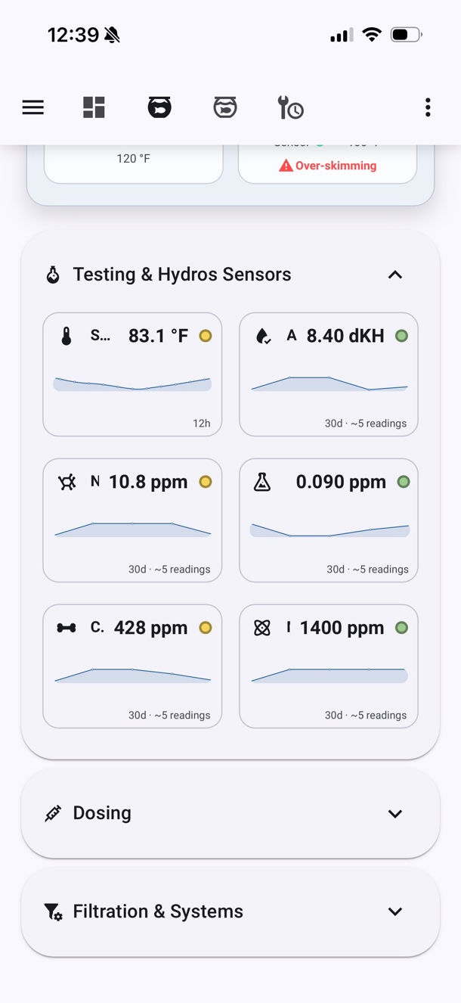  Above are the some of the Hydros Sensors and Home Assistant Input Helpers within the Expander. | 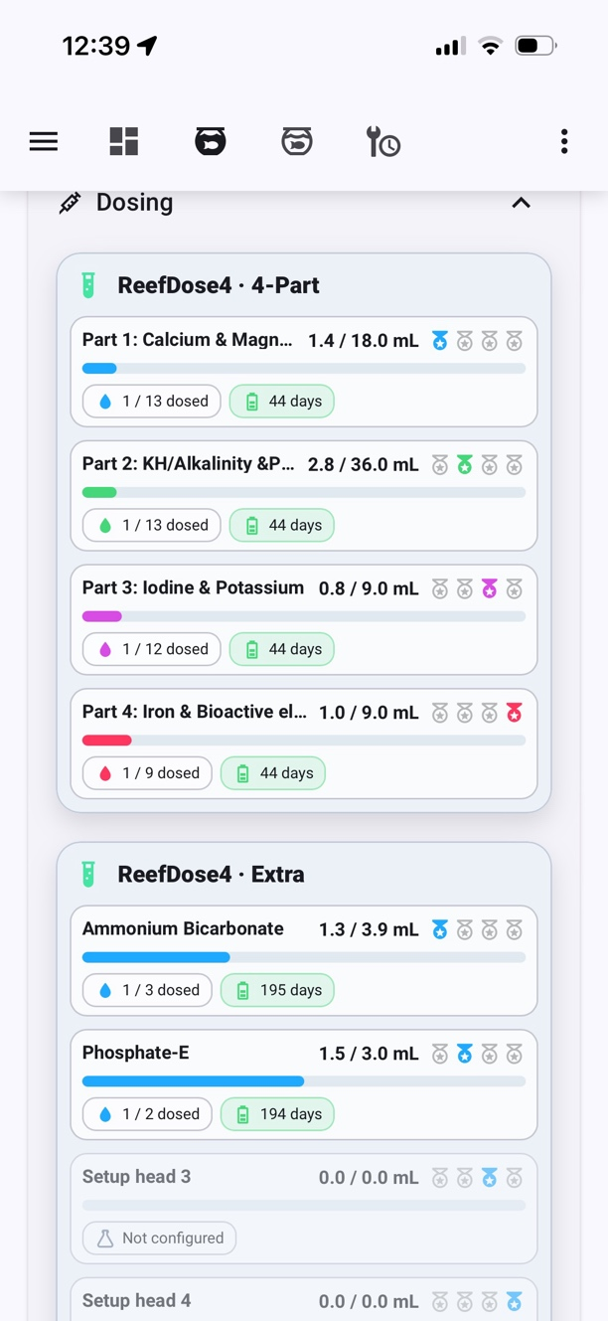  Here are the ReefDose 4 devices that looks a lot like ReefBeat within the Expander.
ReefMat and remaining devices that are running:  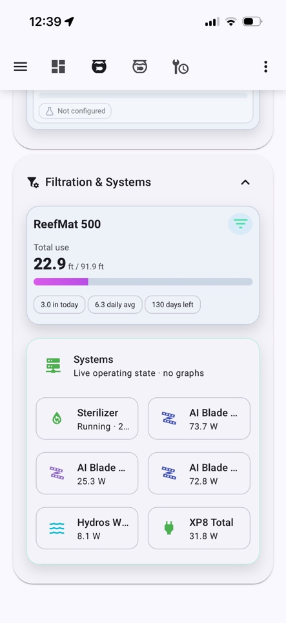 | 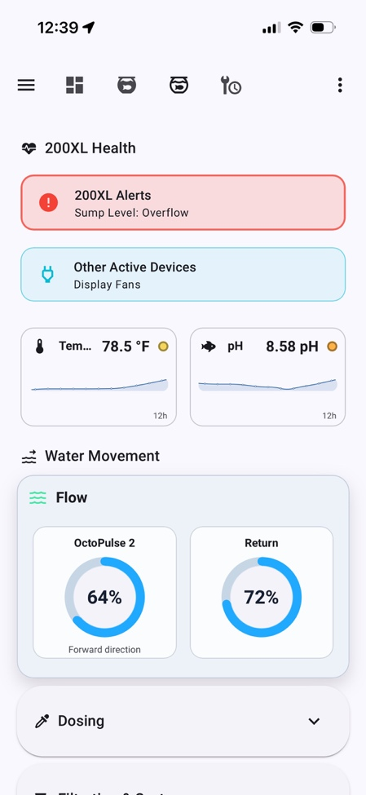  Above is my second aquarium. Same features except there are no Red Sea equipment excpet for the ReefMat – just Hydros controllers.

Next are the maintenance screens. Still sorta working on the ReefBeat maintenance, but probably just use ReefBeat for that. I can still display the status.  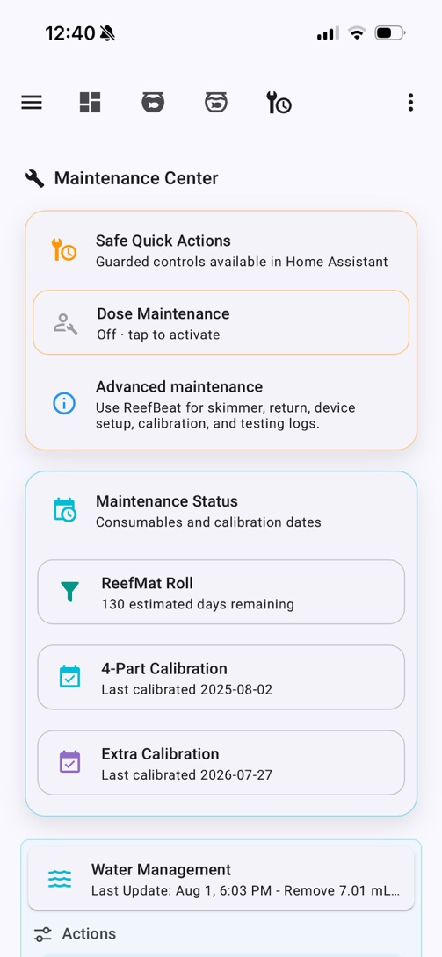 | 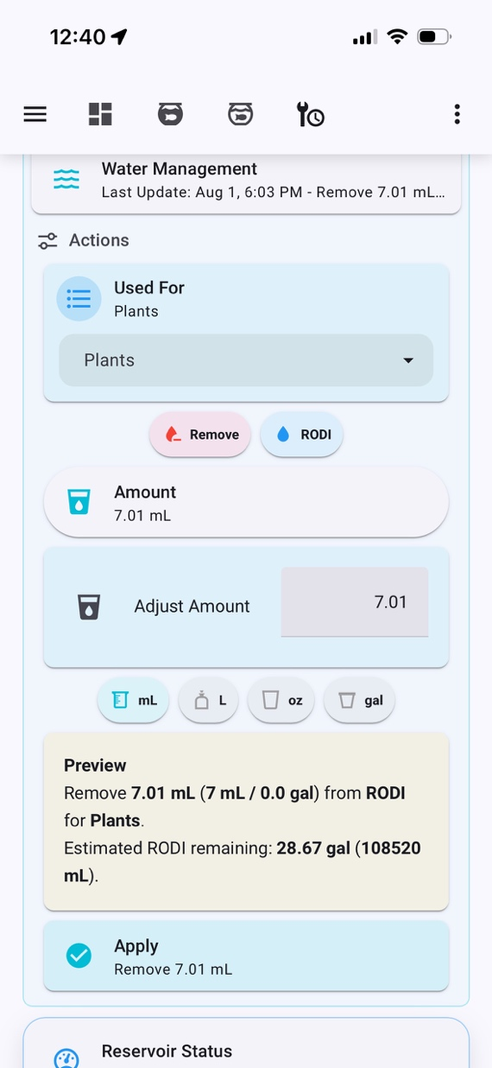  Water management is next. This applies to my mixing station in the garage. RODI water is not only used for ATO but for new Salt mix and water for the plants. It will calculate remaining based on how much I extract.
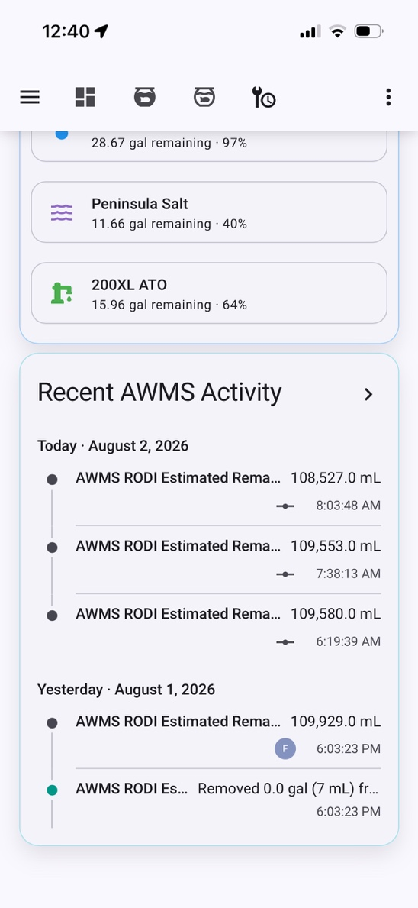
Remaining water in my reservoirs and recent activity.

Aquarium Tablet – same concept as Mobile but on a landscape view of an iPad:


